PROJECT REPORT

DATABASE MANAGEMENT SYSTEMS LAB

**HOTEL MANAGEMENT SYSTEM**

Group Members:

1. Sooraj Kumar CS-201227
2. Yahya jamshed CS-201243
3. Ammar muffadal CS-201239
4. Yalmaz ahmad CS-201237

Introduction:

Are you trapped inside your house due to COVID-19 situation but you want to eat outside food or want to keep your restaurant running while staying at home? Don’t worry we have got your back. We introduce to you a very simple windows application which will help you in selling food and managing your customer’s log. Application can hold six different types of food category and is very easy to use.

Relevance:

This application has a very high scope in restaurants that has online ordering system and looking at the current scenario (COVID-19) it will benefit both restaurant and customers as customers can avail food at good offers and restaurant will also keep working.

ER Diagram:

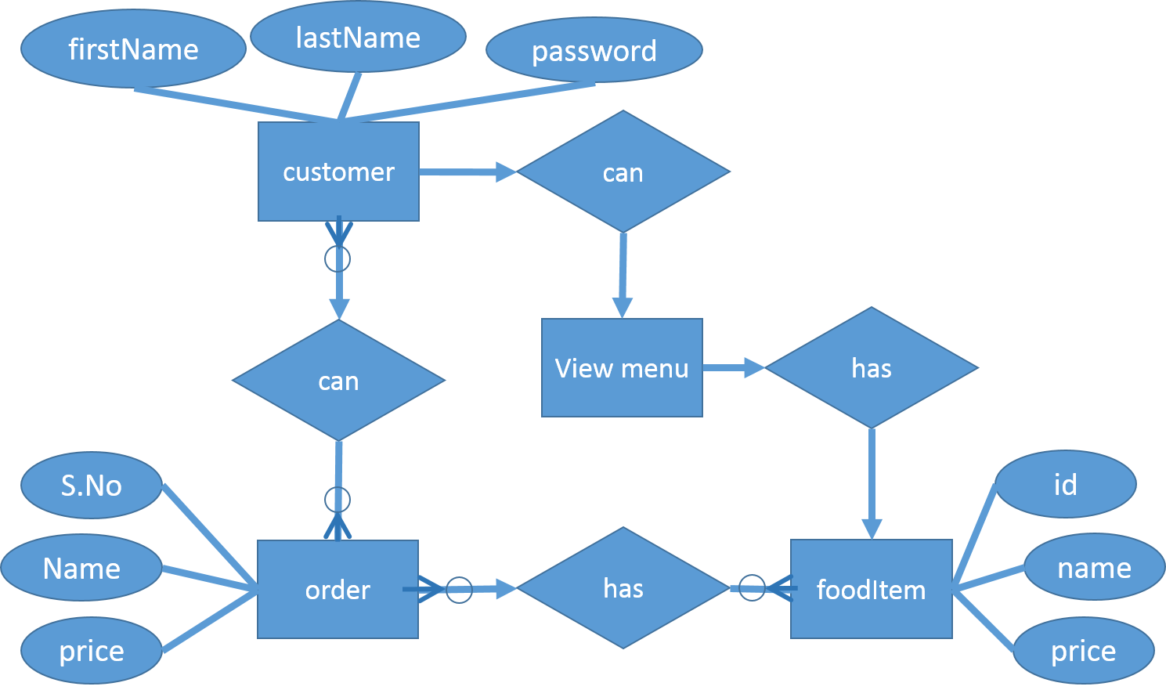

Data Flow Diagram:

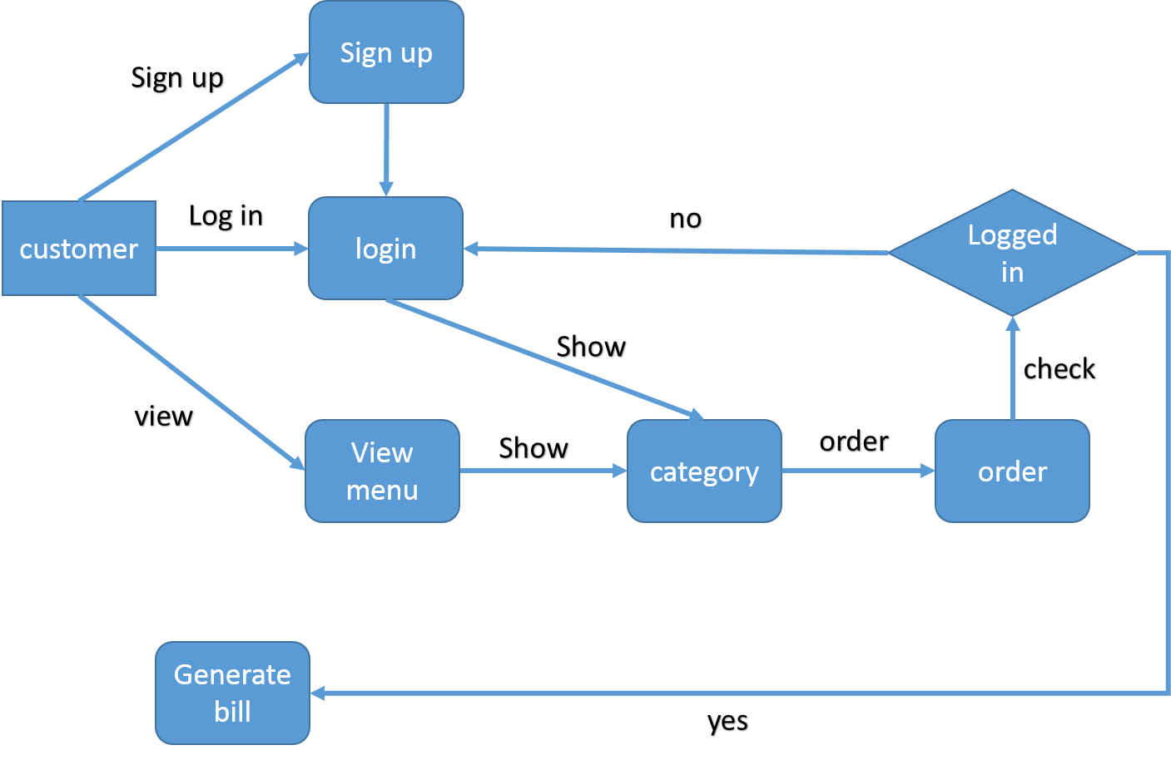

Front-End Design:

Programming language used **C#**

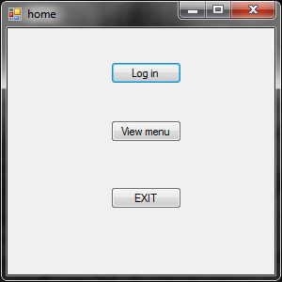

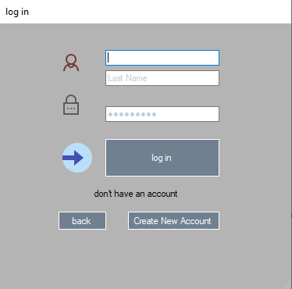

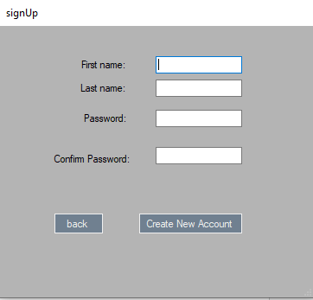

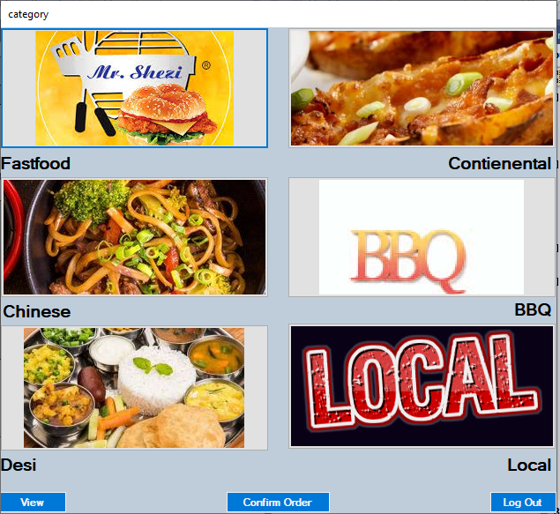

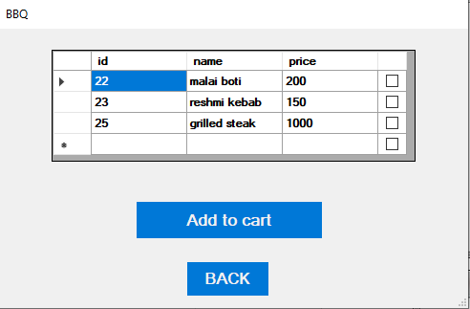

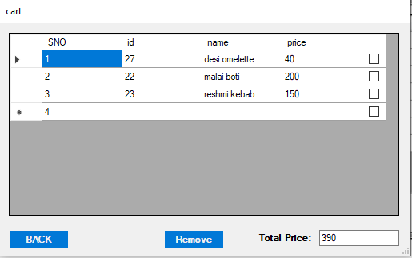

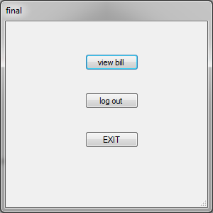

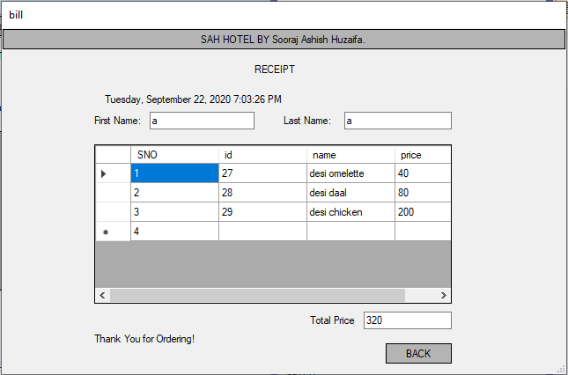

Codes related to Database:

Create table login(firstname varchar(100),lastname varchar(100),password varchar(100));

Create table fastfood(id int,name varchar(100),price int);

Create table cart(id int,name varchar(100),price int);

1. INSERT INTO hotelms.login(firstname,lastname,password) VALUES('" + fnametxt.Text + "','" + lnametxt.Text + "','" + passtxt.Text + "')";
2. SELECT `firstname`,`lastname`,`password` FROM hotelms.login WHERE `firstname` = '" + fnametxt.Text + "' AND `lastname` = '" + lnametxt.Text + "' AND `password` = '" + passtxt.Text + "'";
3. SELECT * FROM hotelms.fastfood;
4. SELECT * FROM hotelms.contienental;
5. SELECT * FROM hotelms.chinese;
6. SELECT * FROM hotelms.bbq;
7. SELECT * FROM hotelms.desi;
8. SELECT * FROM hotelms.local;
9. INSERT INTO hotelms.cart values(@id,@name,@price);
10. DELETE from hotelms.cart WHERE id ='" + item.Cells[1].Value.ToString() + "';
11. SELECT sum(price) as Total from hotelms.cart
12. TRUNCATE TABLE hotelms.cart

Query execution and result:

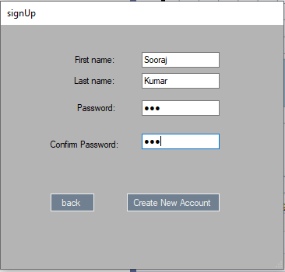

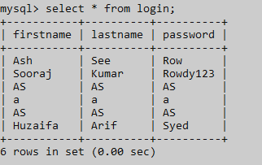

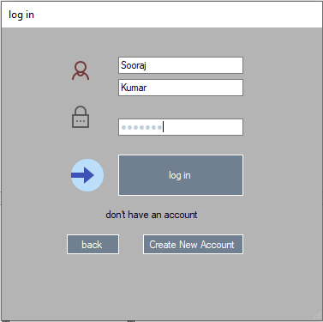

While entering incorrect password.

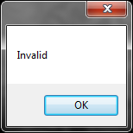

After entering correct password It will bring us to Menu.



3, 4, 5, 6, 7, 8)

Since all works the same so just showing data of fast food

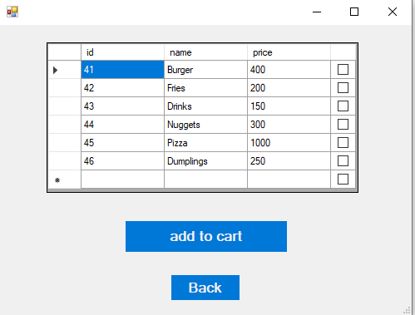

9)

After ordering, This is Cart.

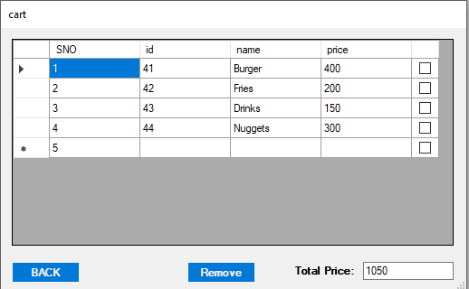

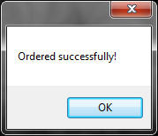

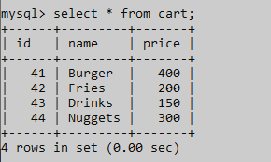

10) After removing Nuggest from Cart.

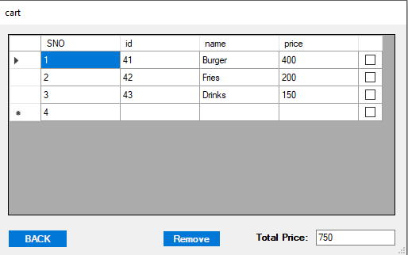

11) Sum Of All Items.

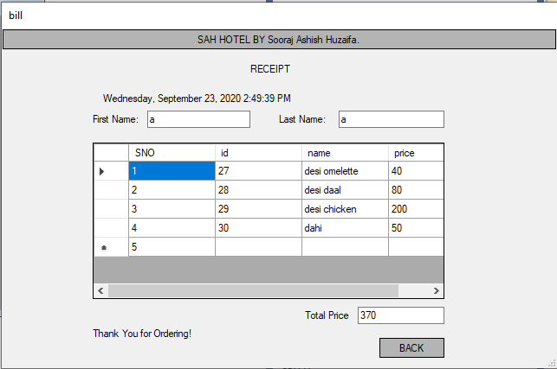

12)Once we are done with our order, Cart will be empty.

